Journal of The British Interplanetary Society, Vol. 44, pp. 371-376,1991.

NUCLEAR SALT WATER ROCKETS: HIGH THRUST AT 10,000 SEC ISP

R. ZUBRIN
Martin Marietta Astronautics, PO Box 179, Denver, CO 80201, USA.
The basis of a novel space propulsion system called a Nuclear Salt Water Rocket (NSWR) is outlined. NS WR is constructed of a bundle of boron-carbide coated pipes, each containing an aqueous solution of uranium or plutonium salt These pipes empty into a single long cylindrical plenum pipe of larger diameter, which terminates in a rocket nozzle. When the rocket is to be fired, the aqueous solution held in the pipe bundles is emptied into the plenum. When the plenum has filled to a certain point, the fluid assembly within it exceeds critical mass and goes prompt supercritical, with the neutron flux concentrated on the downstream end due to neutron convection. Enormous amounts of energy are generated within this region, flashing the solution to steam which then streams down the plenum pipe towards the nozzle, convecting the exponentially growing fission chain reaction with it. As the solution continues to pour into the plenum from the borated storage pipes, a steady-state condition of a moving detonating fluid can be set up within the plenum.
Assuming a solution of 2 atoms of 20% enriched uranium per 100 molecules of water and a fission yield of 0.1% is obtained, the specific impulse produced will be about 7,000 seconds. This is comparable to that available from electric propulsion (EP). However, unlike an EP system, a NSWR is not power limited (since waste heat is eliminated with the propellant) and systems with jet power ratings of thousands of megawatts are obtainable. The NSWR can thus deliver its very high specific impulse at thrust levels of the same magnitude as chemical engines, or about 4 orders of magnitude greater than that of a multi-megawatt EP system. The NSWR system is simple and lightweight. Shielding considerations are minimized by the fact that almost no radioactive inventory travels with the vehicle. On the other hand, the exhaust stream from the NSWR is extremely radioactive, which limits the use of the device to orbit transfer propulsion, despite its high thrust to weight.

1. INTRODUCTION
Present day rocket propulsion systems can be divided into two main types:
- high thrust engines with low specific impulse,
- low thrust engines with high specific impulse.
The first type is exemplified by chemical rocket engines which may have thrusts ranging from 20,000 to upwards of a million pounds, thrust to weight (T/W) ratios of 30 to 60 and specific impulses between 300 and 460 seconds. The second kind is typified by electric propulsion, [1,2] (ion or MPD) systems, with thrusts from 0.5 to 100 lbs, T/W ratios between 0.00002 and 0.002, and specific impulses between 3000 and 10,000 seconds. High thrust is essential for vehicles which lift off of planetary bodies but is also very desirable for space transfer vehicles as it reduces or eliminates the large gravity losses associated with low thrust spiral orbits. Furthermore, if fast trips are desired, very low thrust is intolerable as the time required for the engine to generate the required velocity change will exceed that allocated for the mission. On the other hand, low specific impulse means low exhaust velocity and thus, a small transfer of momentum to the spacecraft for each unit of propellant expended by the engine. Thus, high thrust, low specific impulse systems may require vast amounts of propellant to accomplish a given mission, causing the total mission initial mass in Low Earth orbit (LEO) to be excessive. The mission will therefore require a large number of Heavy Lift Launch Vehicle (HLLV) launches to place in its initial orbit, plus extensive on-orbit assembly, both of which tend to drive the cost of a high energy mission to the point of impracticality.
Mission planners are on the horns of a dilemma by being forced to choose between two systems, each of which has only one of the two required characteristics for an optimum propulsion system. Some promise in dealing with this situation is presented by nuclear thermal rocket (NTR) [3] systems, which offer specific impulses ranging form 900 (solid core) to 2000 (gas core) seconds, and T/W between 0.3 (gas core) and 6 (solid core); in a sense offering a compromise between the benefits and deficiencies of the chemical and electric propulsion systems. Truly ideal, however, would be a system that offered both T/W comparable to chemical systems and specific impulses on the order of that obtained by electric units. The only system examined to date, that has possessed both characteristics if the Orion concept, or nuclear pulse propulsion [4], which operates by detonating a continuous series of atomic or hydrogen bombs to the rear of the spacecraft. The blast energy is absorbed by a specially designed pusher plate and shock absorption mechanism, thereby pushing the spacecraft along. The United States had a programme to develop the Orion concept in the late 1950s and early 1960s but the Test Ban Treaty of 1963, which prohibited detonation of nuclear bombs in space, made the testing or use of Orion illegal, and the project had to be dropped.
The fact that, of concepts examined to date, only the mighty Orion possessed both high thrust and high specific impulse, is itself significant. The product of thrust and specific impulse is proportional to the system power, and an engine which is maximizing both must be a titanic power source. For example, consider an engine with 250,000 lbs thrust and an Isp of 5000 seconds. The power level required to sustain this performance would be 28,000 MW. Only the raw thermal energy of nuclear explosions could sustain such a power output Any attempt to

produce this kind of power and convert it to electricity would result in engine masses well over 100,000 tonnes. This absurdity would, in turn, require something like 1000 HLLV launches simply to place the engine (let alone the propellant) into LEO to start the mission.
The requirement is for an engine which can release power equal to a series of nuclear detonations, without using elements with characteristics similar to nuclear weapons. The Nuclear Salt Water Rocket (NSWR) is such a concept
2. THE NUCLEAR SALT WATER ROCKET (NSWR)
The Nuclear Salt Water Rocket (NSWR) is constructed of a bundle of boron-carbide coated pipes each containing an aqueous solution of uranium or plutonium salt These pipes, in turn, all empty into a single long cylindrical plenum pipe of larger diameter, which terminates in a rocket nozzle. When the rocket is to be fired, the aqueous solution held in the pipe bundles is emptied into the plenum (fig. 1). When the plenum has filled to a certain point, the fluid assembly within it exceeds critical mass and goes prompt supercritical, with the neutron flux concentrated on the downstream end due to convection by the moving fluid. Enormous amounts of energy are generated within this region, flashing the solution to steam which then streams down the plenum pipe towards the nozzle, converting the exponentially growing fission chain reaction with it As the solution continues to pour into the plenum from the borated storage pipes, a steady-state condition of a moving detonating fluid can be set up within the plenum.
In a sense, the NSWR is similar to a high thrust chemical propulsion system in that it consists of a fluid which is introduced into a combustion chamber, where it detonates to produce a high energy gas exhaust. The difference is that the amount of energy available per unit mass of chemical fuels is limited by the energy of the chemical reaction, while that of the NSWR is determined by the yield of the fissile component of its propellant, which may be up to five orders of magnitude greater. This implies that the upper limit of the theoretical performance of an NSWR would be an Isp several hundred times as great as the best possible chemical fuels, with comparable levels of thrust.
Clearly, the NSWR is not a bomb, and its use would not be affected by the Test Ban Treaty. Moreover, while producing a power output comparable to Orion through its continuous fission fizzle, the NSWR is actually more desirable as a propulsion system since the thrust applied is steady state and does not subject the payload spacecraft to large repeated shocks caused by nuclear pulse propulsion.
- METHOD OF ANALYSIS
In order to be able to analyze the NSWR completely, the requirement is a computer code which solves the coupled multi-group neutron transport equation, hydrodynamic equation of motion, and heat transfer equation as a single system. Unfortunately, as the time and resources required to write this were not available, the approach adopted was to use certain analytic approximation to gain insight into the NSWR performance and behaviour.
Approximations adopted include the use of single group neutron diffusion theory, with a convective term added to the standard equation. This is reasonable since the neutron spectrum in the aqueous fissile propellant would be highly thermalized due to the large amounts of hydrogen present in the water. A cruder approximation is to assume that the density and velocity of the moving fluid is constant This is close to being true until the point in the plenum is reached where detonation occurs, after which it is untrue except inasmuch as the chamber cross sectional profile can be shaped to make it so. However, this does not matter too much as, once detonation has occurred, the fluid is heated so rapidly to its desired energy that the accuracy of the neutronic calculation for fluid positions significantly downstream of the detonation point becomes academic. It is also assumed that the column of propellant moving through the chamber is composed of the aqueous fissile mixture, whereas, in reality, a layer of pure water would be sprayed around the perimeter of the column to form a moving neutron reflector and to protect the plenum walls and throat from the very high temperatures generated in the detonating solution. Ignoring this layer actually gives our calculation a conservative slant, as the neutron reflection it provides would reduce the requirements о size and/or enrichment needed to achieve criticality within the propellant column.

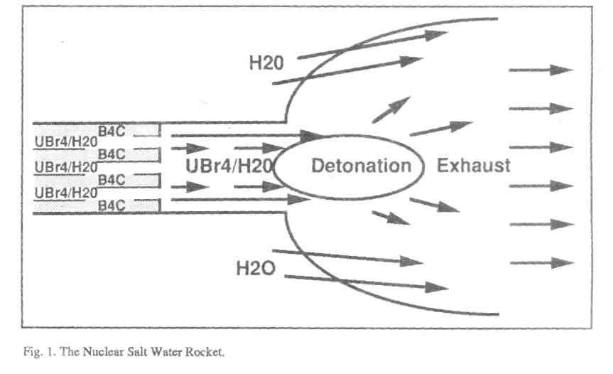
Utilizing these assumptions, the single group neutron diffusion equation for a moving fluid medium can be written:

(Grad)² Ф + В² Ф = U (Grad) Ф/D (1)
where Ф is the single group neutron flux, B² is the material buckling (equal to (υ∑_{f} - ∑_{a})/D), U is the dimensionless fluid velocity (equal to the actual fluid velocity divided by the speed of a thermal neutron), and D is the diffusion coefficient, calculated in the normal way using diffusion theory and thermal cross sections.
Assuming that D, U, and В are constants and that U is entirely in the "z" (lengthwise) direction, this equation can be solved by separation of variables. Let Ф = RZ, where R represents the functional dependence of the flux on the "r" (radial) direction within the plenum channel, while Z represents the functional dependence of Ф on the "z" position, then we find:
dRW+(l/r)dR/dr + A²R = 0 (2)
d²Z/dz² - (U/D)dZ/dz + L²Z - 0 (3)
and
A² + L² - B² (4)
The solution of equation (2) is:
R-C₁J₀(Ar) (5)
where C, is an arbitrary constant and J₀ is the zeroth order Bessel function. Applying the boundary condition of setting the flux equal to zero at toe edge of the propellant column, we find that:
A-v₀/r₀ (6)
where v₀ = 2.405... is the first zero of the zeroth order Bessel
function and r₀ is the radius of the propellant column. The results of this solution are displayed graphically in fig.2. The solution to equation (3) is:
Z = C₂(e^{kz})(exp(sqrt(k²z²-L²z²)) – exp(-sqrt(k²z²-L²z²)) (7) where C₂ is an arbitrary constant and
к = U/(2D) (8)
We define,
M = abs(sqrt(k²-L²)) (9)
then if K² - L² is less than zero (7) becomes
Z = C₂e^{kz}sin(Mz) (10)
while if (k²-L²) is greater than zero (7) becomes;
Z-C₂e^{kz}sinh(Mz) (11)
and if (k²-L²) equals zero the solution to (3) under toe given boundary conditions is;
Z = C₂(kz)e^{fa} (12)
The linear dependence of toe flux profiles resulting from equations (10), (11) and (12) are displayed graphically in fig. 3.
It can be seen that if U = 0, then к = 0, and the solution degenerates to a simple sine function dependence in the z direction, just as in the case of a bare cylindrical static reactor. As U increases, к increases, and the sine curve becomes distorted by the exponential function e^{kz}, which increases toe flux near toe downstream end of the reacting assembly. When U becomes high enough that к is greater than L, then toe sine dependence is lost and toe flux increases without limit downstream as toe product of an exponential times a hyperbolic sine functions. By increasing k the slope of this flux increase can be

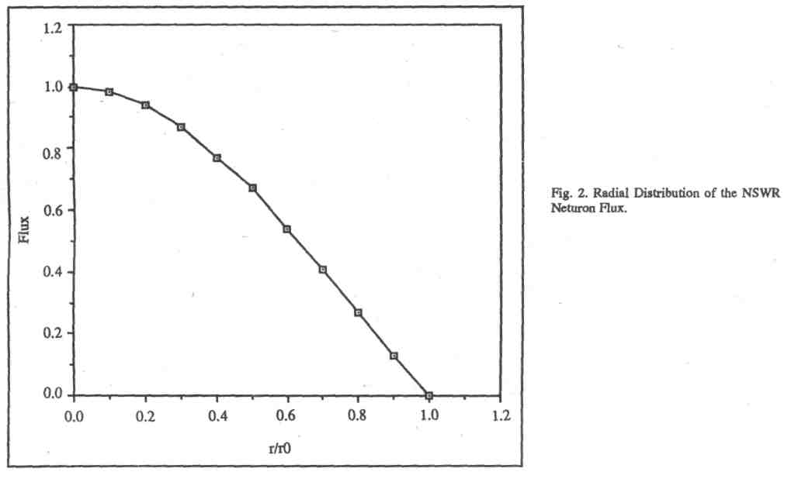

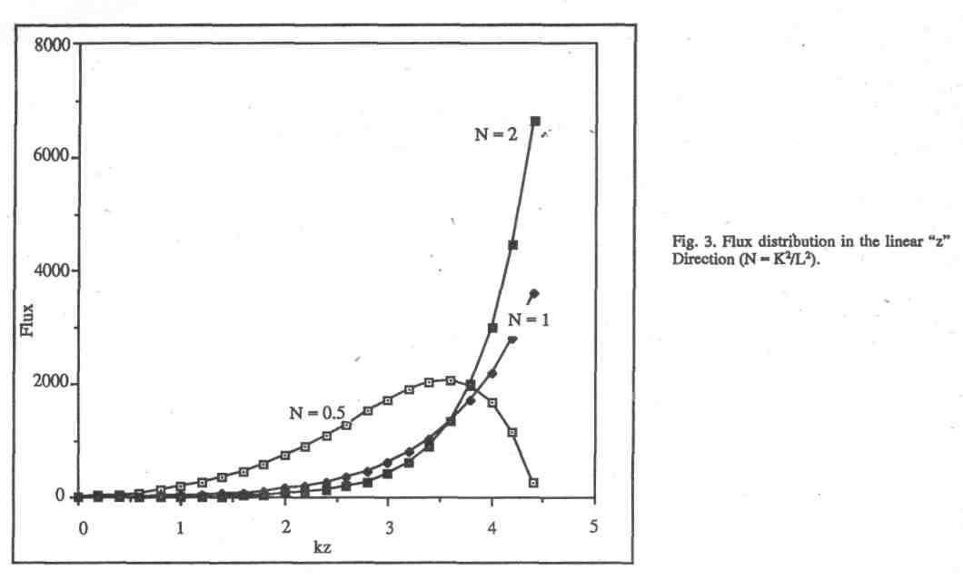

made as steep as desired, creating a condition of virtually instantaneous detonation of the fluid once a certain "z" position is reached.

It may be observed that the energy content of the fluid is proportional to the integral in the z direction of the power, which in turn is proportional to the flux. The Bessel function radial dependence of the power distribution, therefore, scales the energy content of the fluid accordingly. This has the effect
of concentrating the power release and thus the highest temperatures in the centre of the fluid, with power falling off to zero as the wall is approached. By combining this effect with the addition of a layer of fast-flowing water injected along the plenum wall, the wall can be insulated from the extremely high temperatures and power densities generated in the centre of the propellant column. The energy distribution in the linear z direction is depicted in fig. 4.

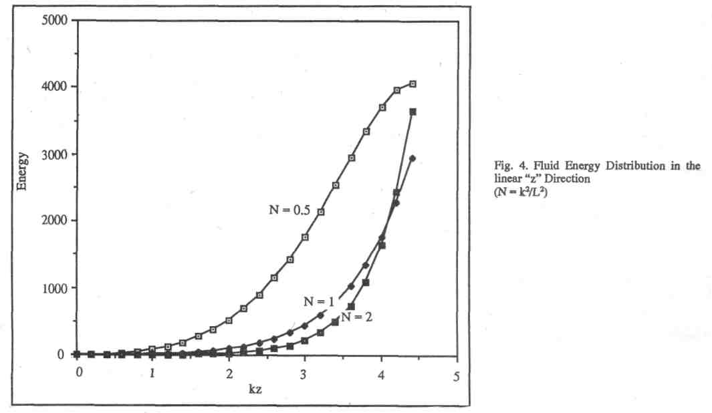
- RESULTS FOR A SAMPLE NSWR CONFIGURATION

A sample NSWR configuration can now be analyzed, assuming the propellant selected is a solution of 2% by number uranium bromide salt solution in water (sea water is 3% by number NaCl). The uranium is enriched to 20% U²³⁵, which is much more than 3% commonly used in commercial pressurized water reactors (PWR) but much less than the 93% commonly used in space nuclear power systems. Using the standard techniques of diffusion theory it can be calculated that for this configuration B² = 0.6136 cm⁻² and D = 0.2433 cm. If r₀, the radius of the reaction plenum, is taken to be 3.075 cm, A² = 0.6117 cm² and L² = 0.0019. As an exponential detonation is desired let us take k² = 2L² = 0.0038 cm². Then к = U/2D = 0.062 cm⁻¹, and U = 0.03. Taking the velocity of a thermal neutron as 2200 m/s, this implies that the fluid velocity needs to be 66 m/s. Since this is only about 4.7% of the sound speed of room temperature water, it should be possible to spray the water into the plenum chamber at this velocity. The total rate of mass flow through the chamber is about 196 kg/s.
If there was complete fission yield of the U²³⁵ in solution, the total energy content of the fluid would be about 3.4 x 10¹²J/ kg. If it is assumed, instead, that the actual yield is only 0.1%, (perhaps up to 0.2% at the centre of the propellant column, down to zero at the edge), this will not significantly affect the value of the material buckling during the burn. The energy content of the detonating fluid is then 3.4 x 10⁹ J/kg. Assuming a nozzle efficiency of 0.8, this results in an exhaust velocity of 66,000m/s, or a specific impulse of 6,730 seconds. The total jet power output of the engine is 427,000 MW, and the thrust is 12.9 MN or 2.9 Mb.
For an exponential detonation to take hold, we desire (kz) to be large, say kz = 4 at the plenum exit. Since in the above calculation, к = 0.062 cm⁻¹, this means that the plenum must be 65 cm long. '
- MISSION ANALYSIS
A good example to use in comparing the merit of a NSWR with other advanced propulsion systems is a manned mission to Titan, the largest satellite of Saturn. The proposed mission is conducted as follows:
A 300 metric tonne manned spacecraft is injected out of LEO using an advanced propulsion system to achieve a hyperbolic excess velocity of 10.77 km/s, putting it on a 4 year trajectory to Titan. Arriving at Titan, the ship aerocaptures with an entry velocity of 6.4 km/s and begins airbreathing winged flight, using a nuclear thermal rocket (NTR) engine to heat the indigenous atmosphere to produce jet thrust After an exploratory cruise through the atmosphere, the ship lands on Titan. While the astronauts are conducting their activities on Titan, the ship fills its tanks with methane from Titan's atmosphere, which it will use as NTR propellant to achieve a 4 year return trajectory to Earth. Upon arrival at Earth, the advanced propulsion system is used again to decelerate the ship into LEO. This system of using NTR heated Titanian methane for Earth return is by far the best way to conduct a Titan mission [5], as it is freely available, and, in addition to giving the ship unlimited mobility in Titan's atmosphere, it also produces the lowest initial mass in LEO (IMLEO) regardless of the advanced propulsion system chosen for trans-Saturn injection (TSI).
Table 1 shows a comparison of the results for this mission for a variety of advanced propulsion options. All numbers represent masses in metric tonnes.

The engine mass given under the heading "Space" repre-
TABLE1: Manned Missions to Wan Using Advanced Propulsion

Option | Engines Space/Ascent |  | Propellant | Tanks | IMLEO
NEP | 100 | 11.6 | 190.7 | 7.6 | 609.9
NSWR | 33 | 7.6 | 41.8 | 1.7 | 384.0
NTR | 22 | 0.0 | 465.0 | 46.5 | 833.6
GCR | 100 | 10.9 | 155.0 | 15.5 | 581.5
CRYO | 10 | 22.6 | 1060.0 | 106.0 | 2207.0
sents the mass of the advanced propulsion system used for TSI and Earth orbital insertion (EOI), while that under "Ascent" represents the mass of the methane NTR used for Titan ascent and trans-Earth injection (TEI). The methane NTR has an Isp of 600 s and a T/W ratio of 10 (the higher density of methane increases the T/W of such a system relative to a conventional hydrogen heating NTR), and was sized so as to give the ship a T/W of 1.4 when lifting off of Titan. In the case of the cryo (cryogenic LOX/H2) option, the methane NTR was also used to achieve EOI. Since propellants for all of the advanced propulsion systems considered (argon for NEP, water for NSWR, hydrogen for NTR and GCR) are available at Titan, only the propellant required for TSI is shown. (The propellant required for EOI has a minor influence, however, through its impact on the required mass of the methane NTR used for TEI).
The following assumptions were used for each of the advanced propulsion systems considered.
a. NEP: The Nuclear Electric Propulsion (NEP) system was
assumed to consist of a 20 MW_{jet} system with an "alpha" value of 5 kg/kW_{jet}, which is about a factor of 10 lighter than the current state of the art Argon was the propellant assumed, with a specific impulse of 5000 seconds and a tankage fraction of 0.04. Even with 20 MW_{jet} this system must still spend about 60 days spiralling out of LEO, adding 120 days to the round trip time, and causing Edelbaum equation delta-Vs to be used to approximate the large gravity losses experienced.
b. NSWR: The NSWR system sued was that already presented
in the sample case outlined earlier. It has a thrust of 2.9 Mlb,
and a T/W of 40 is assumed. The specific impulse is 6730 s,
and the tankage fraction is 0.04. The very high thrusts inherent in the NSWR causes this system to depart LEO
with an acceleration of 3.4 Earth g's.
с NTR: The NTR system chosen is an enlarged advanced hydrogen propelled Phoebus class engine (Phoebus was 5000 MW) with a power of 7000 MW, a T/W of 7, an Isp of 950 s and a tankage fraction of 0.1. The NTR engine was sized so as to give the ship a T/W of 0.18 in LEO, allowing for an impulse departure with small gravity losses. The NTR system has an ascent engine mass of 0.0 because the same NTR engines used with hydrogen can also be used with Titanian methane.
d. GCR: The Gas Core Reactor (GCR) chosen uses hydrogen
propellant and has an Isp of 2500 s, a T/W of 1, a tankage
fraction of 0.1, and was sized to have a ship T/W in LEO of
0.18.
e. Cryo: The cryogenic chemical propulsion system uses LOX/H2propellant and has an Isp of 480 s, aT/W of 50, and a tank fraction of 0.06. T/W in LEO is 0.23 to keep gravity losses to a minimum.

It can be seen that the NSWR has by far the lowest IMLEO for this mission, being 34% lower than the GCR and 37% less than the NEP, its two closest competitors. If indigenous methane had not been used for Earth return, the advantage of the NS WR would be greatly increased, as it has a much higher Isp than the GCR and it does not suffer the large gravity losses that affect the NEP system.

6. FUEL AND RADIOACTIVITY
In the mission described, the NSWR used 83.6 tonnes of aqueous propellant (41.8 for each of TSI and EOI), 16.7 tonnes out which is uranium. Of this uranium, 3.34 tonnes are actually fissile U²³⁵. This is rather a large amount of U²³⁵ to expend on a single mission but if NSWRs should come into use, large amounts of Pu²³⁹ or U²³³ could be bred (out of U²³⁸ or cheap Th²³², respectively) in either fission breeder reactors or (much better) fusion/fission hybrid reactors. These fissiles could serve equally well in an NSWR as U²³⁵ and could be made cheap enough that propellant cost would not be a significant problem.
The exhaust of the NSWR is highly radioactive, as no attempt has been made to retain the fission products within the engine, however, with an exhaust velocity of 66 km/s, the radioactive products are emitted with a velocity far exceeding the escape velocity of the Earth and, providing the engine was directed to thrust perpendicular to the radial vector connecting the spacecraft in LEO to the Earth's centre (i.e. tangent to the direction of circular orbital velocity), the amount of contaminant reaching the Earth could be insignificant It is thus appropriate to contemplate using the NSWR for LEO departure. Of course, if public concern prevented such an application, NSWRs could still be used on high energy missions by boosting the spacecraft first to a hyperbolic excess velocity of say 3 km/s with an NTR, and then firing the NSWR a 4 days later when the spacecraft was a million kilometres away from Earth.
While the exhaust of the NSWR is radioactive, the engine itself need not be, provided that it is made of low activation materials such as graphite or silicon carbide. Once the engine is turned off, there is no radioactive inventory present to endanger the crew.
7. THE NSWR AND INTERSTELLAR TRAVEL
The above engine analysis assumed a very low yield of 0.1% and a modest enrichment of 20%. It is interesting to contemplate what might be the potential ultimate performance of a NSWR if more optimistic values are assumed.
Consider for example, an NSWR utilizing a 2% uranium bromide solution with 90% enriched U²³³, and obtaining a 90% fission yield. Assuming a nozzle efficiency of 0.9, the exhaust velocity of this system will be 4725 km/s, or about 1.575% of the speed of light (a specific impulse of 482,140 seconds). If the 300 tonne Titan mission spacecraft is endowed with 2700 tonnes of propellant (for a mass ratio of 10) a maximum velocity of 3.63% of speed of light could be obtained, allowing the ship to reach Alpha Centauri in about 120 years. Deceleration could be accomplished without the use of substantial amounts of rocket propellant by using a magnetic sail [6] (or "magsail") to create drag against the interstellar medium.
In a more ambitious approach, one could envisage a group of interstellar emigrants selecting a small ice asteroid with a mass of 30,000 tonnes and using it as propellant (together with 7,500 tonnes of uranium obtained elsewhere) for a 300 tonne spacecraft. In this case the ship could obtain a final velocity of about 7.62% light speed, and reach Alpha Centauri in about 60 years. While this might seem an excessive time for a mission, it would allow some, at least, of a group of astronauts who initiated the trip in their twenties to be alive a the conclusion of the journey, while their first generation children would still be in their prime. The original purpose of the mission could thus be reasonably expected to be still understood by travellers, as there would have been direct cultural transmission from the starting crew to the actual arriving colonists.

8. CONCLUSION
The NSWR is a potentially practical system which offers the combined advantages of possessing a specific impulse as high as the best electric propulsion system and a thrust/weight comparable to the best high thrust chemical engines. Such a system would be enormously beneficial for a host of high energy deep space missions. What is needed is a more detailed analysis utilizing sophisticated computational fluid dynamics and multi-group neutronics codes to obtain a deeper understanding of the NSWR and its ultimate potential performance.

REFERENCES

- RJ.Iahn, "Physics of electro propulsion”, McGraw Hill, NewYoik, NY, 1968.
- J. Sercel and S. Kiauthamer, "Multiraegawatt Nuclear Electric Propulsion; First Order System Design and Performance Evaluation", AIAA Space Systems Technology Conference, San Diego, CA, June 9-12,1986.
- S.K. Borowski, "Nuclear Propulsion - A Vital Technology for the Exploration of Mars and the Planets Beyond", AAS 87-210, Proceedings of the Case for Mars III conference, published by the American Astronautical Society, San Diego, CA 1989.

- A JR. Martin and A. В ond, "Nuclear Pulse Propulsion: A Historical Review of an Advanced Propulsion Concept", JBIS, 32, pp. 283-310,1979.
- R.M. Zubrin, "Missions to Mars and the Moons of Jupiter and Saturn Utilizing Nuclear Thermal Rockets with Indigenous Propellants", AIAA 90-0002, 28th Aerospace Sciences Meeting, Reno, NV, January 8-11, 1990.
- RM. Zubrin and D.G. Andrews, "Magnetic Sails and Interplanetary Travel", AIAA 89-2441, AIAA/ASME 25th Joint Propulsion Conference ,Monterey, CA, July 10-12,1989.

