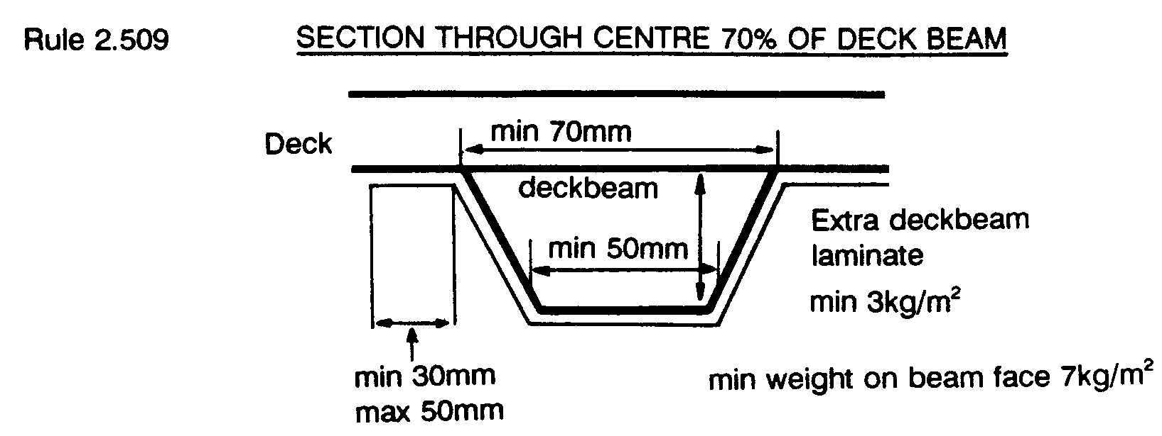
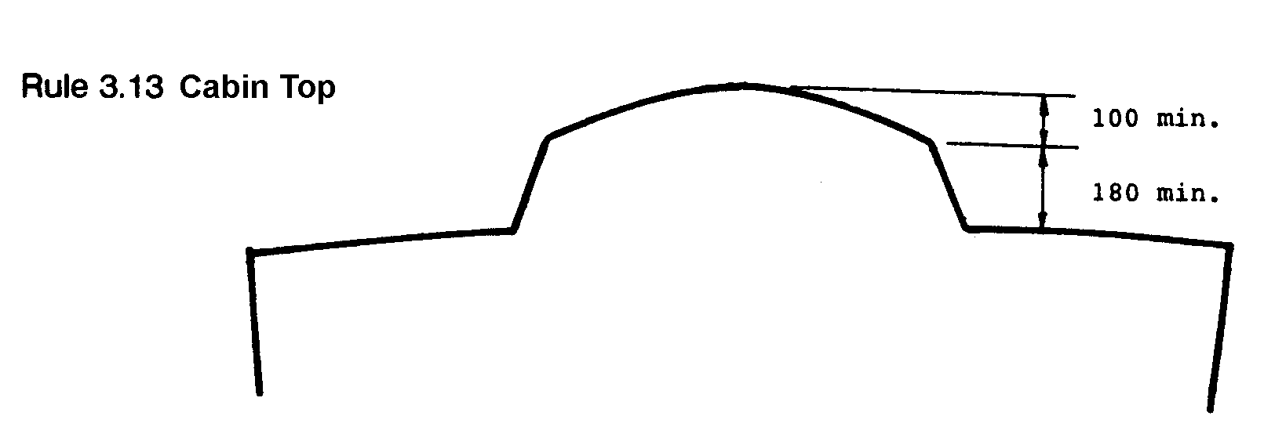
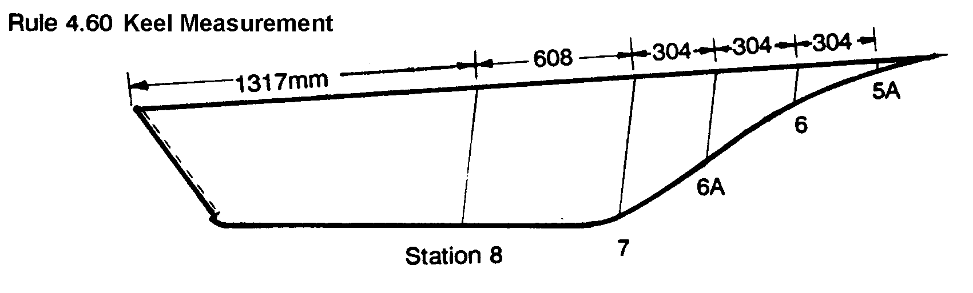
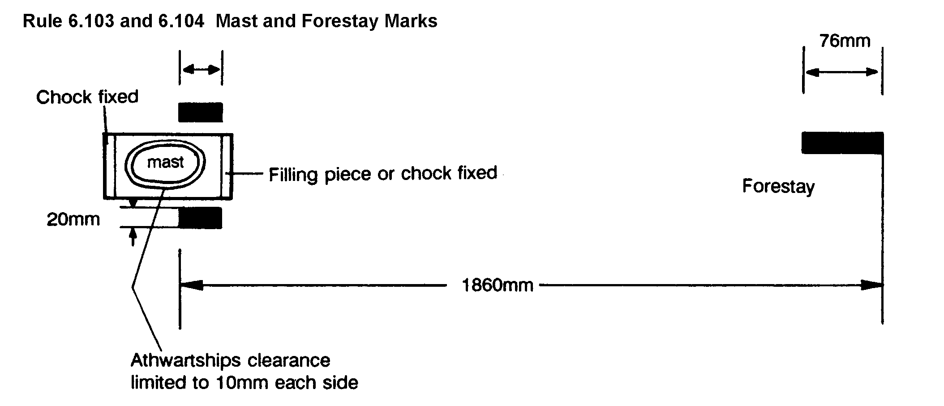

Rule 2.504 Keel Reinforcement

Rule 5.10 Rudder
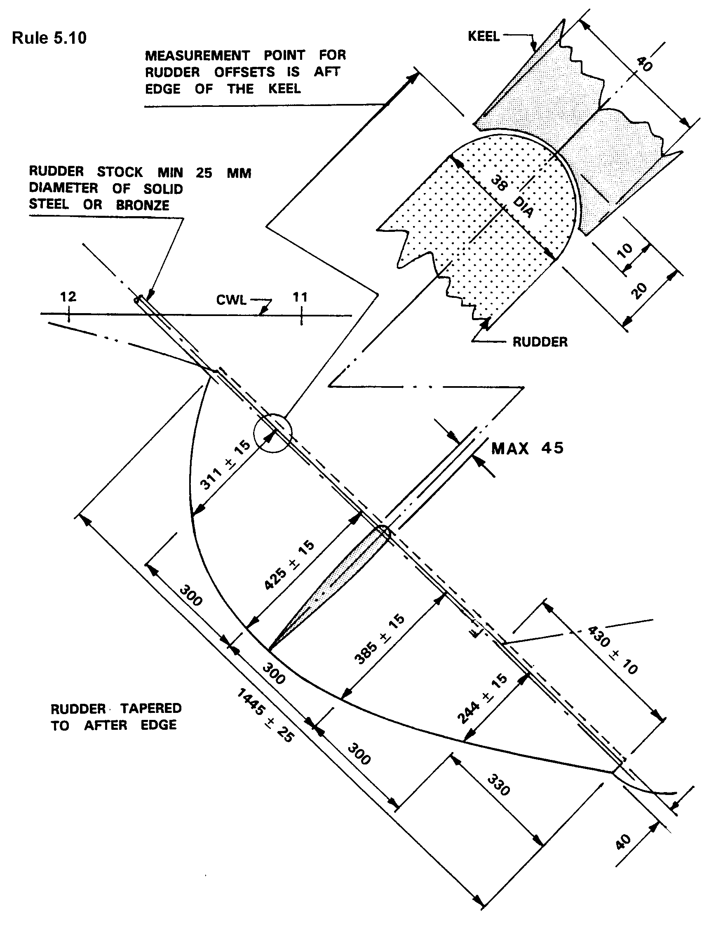
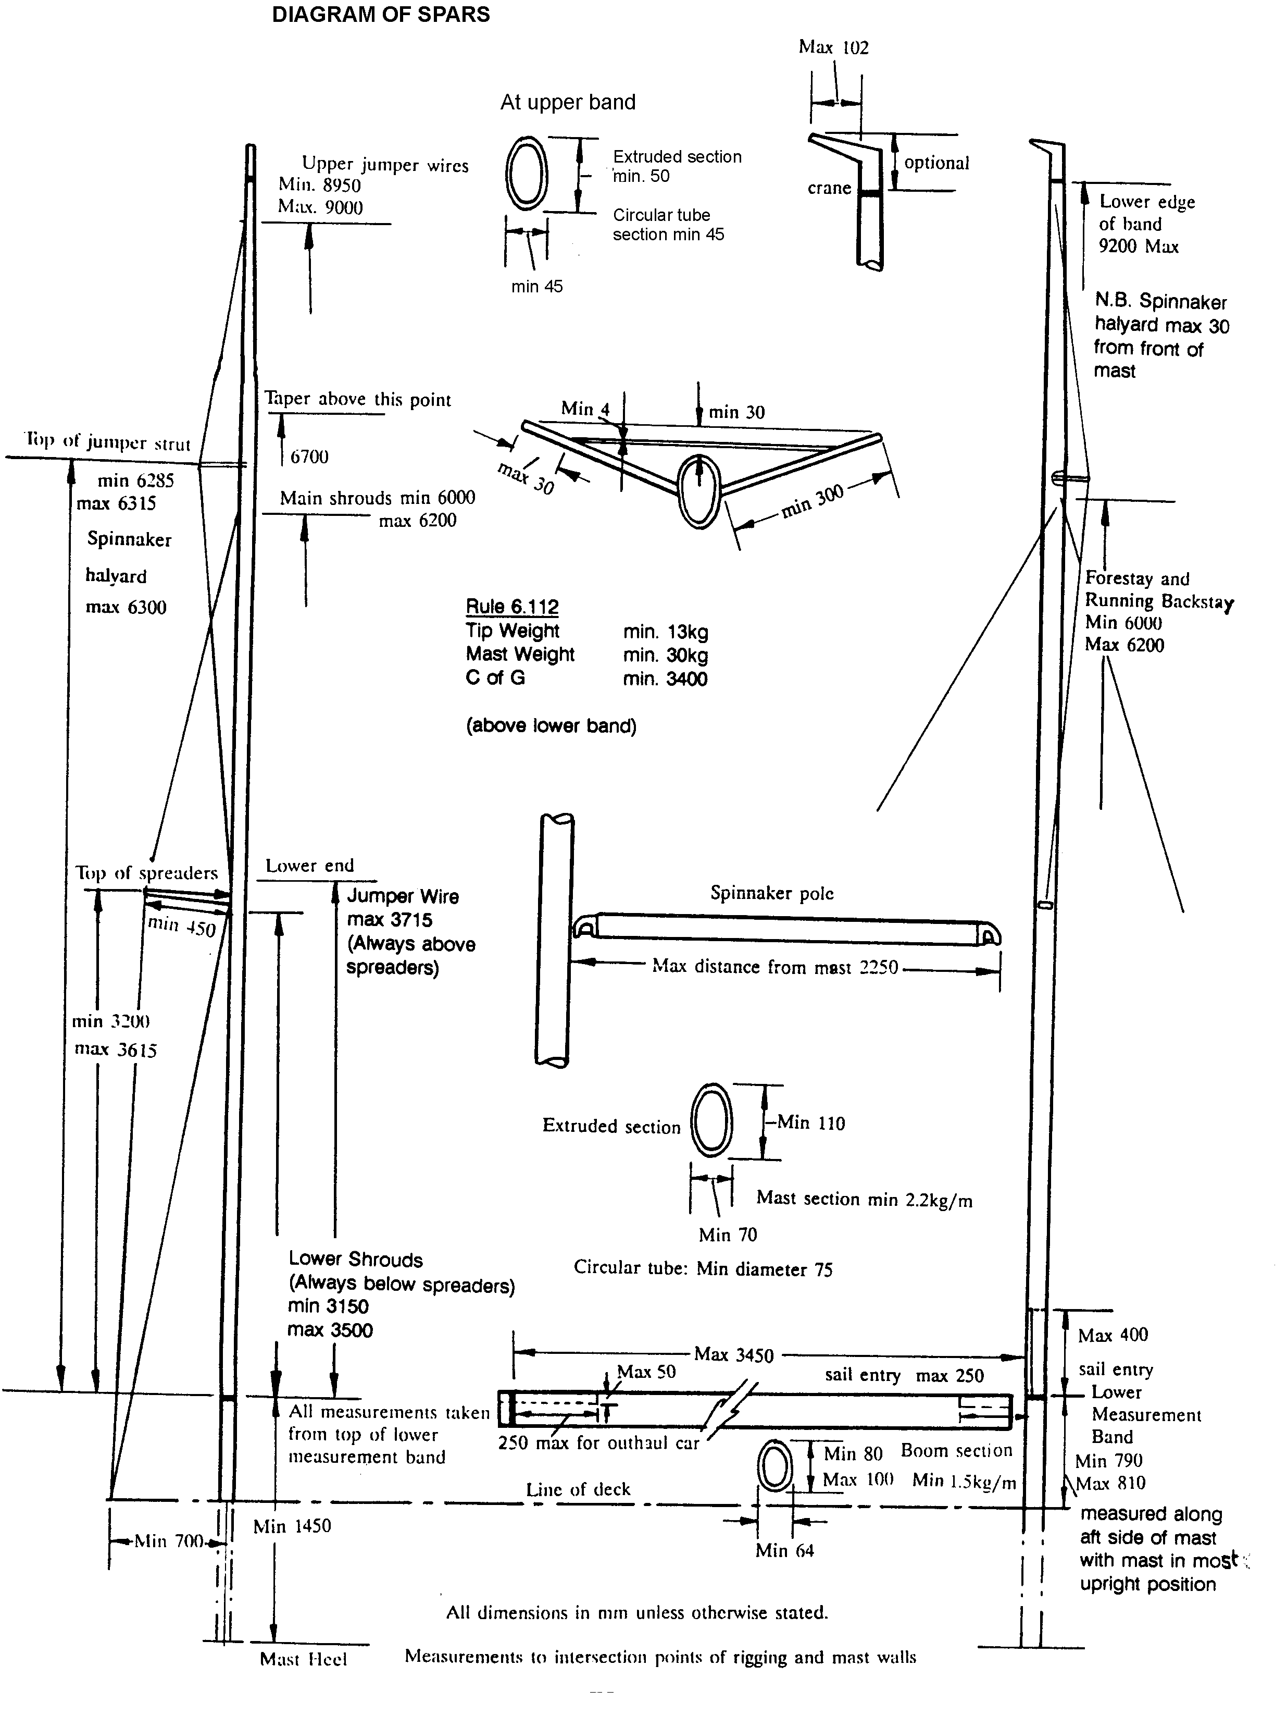
Rule 6

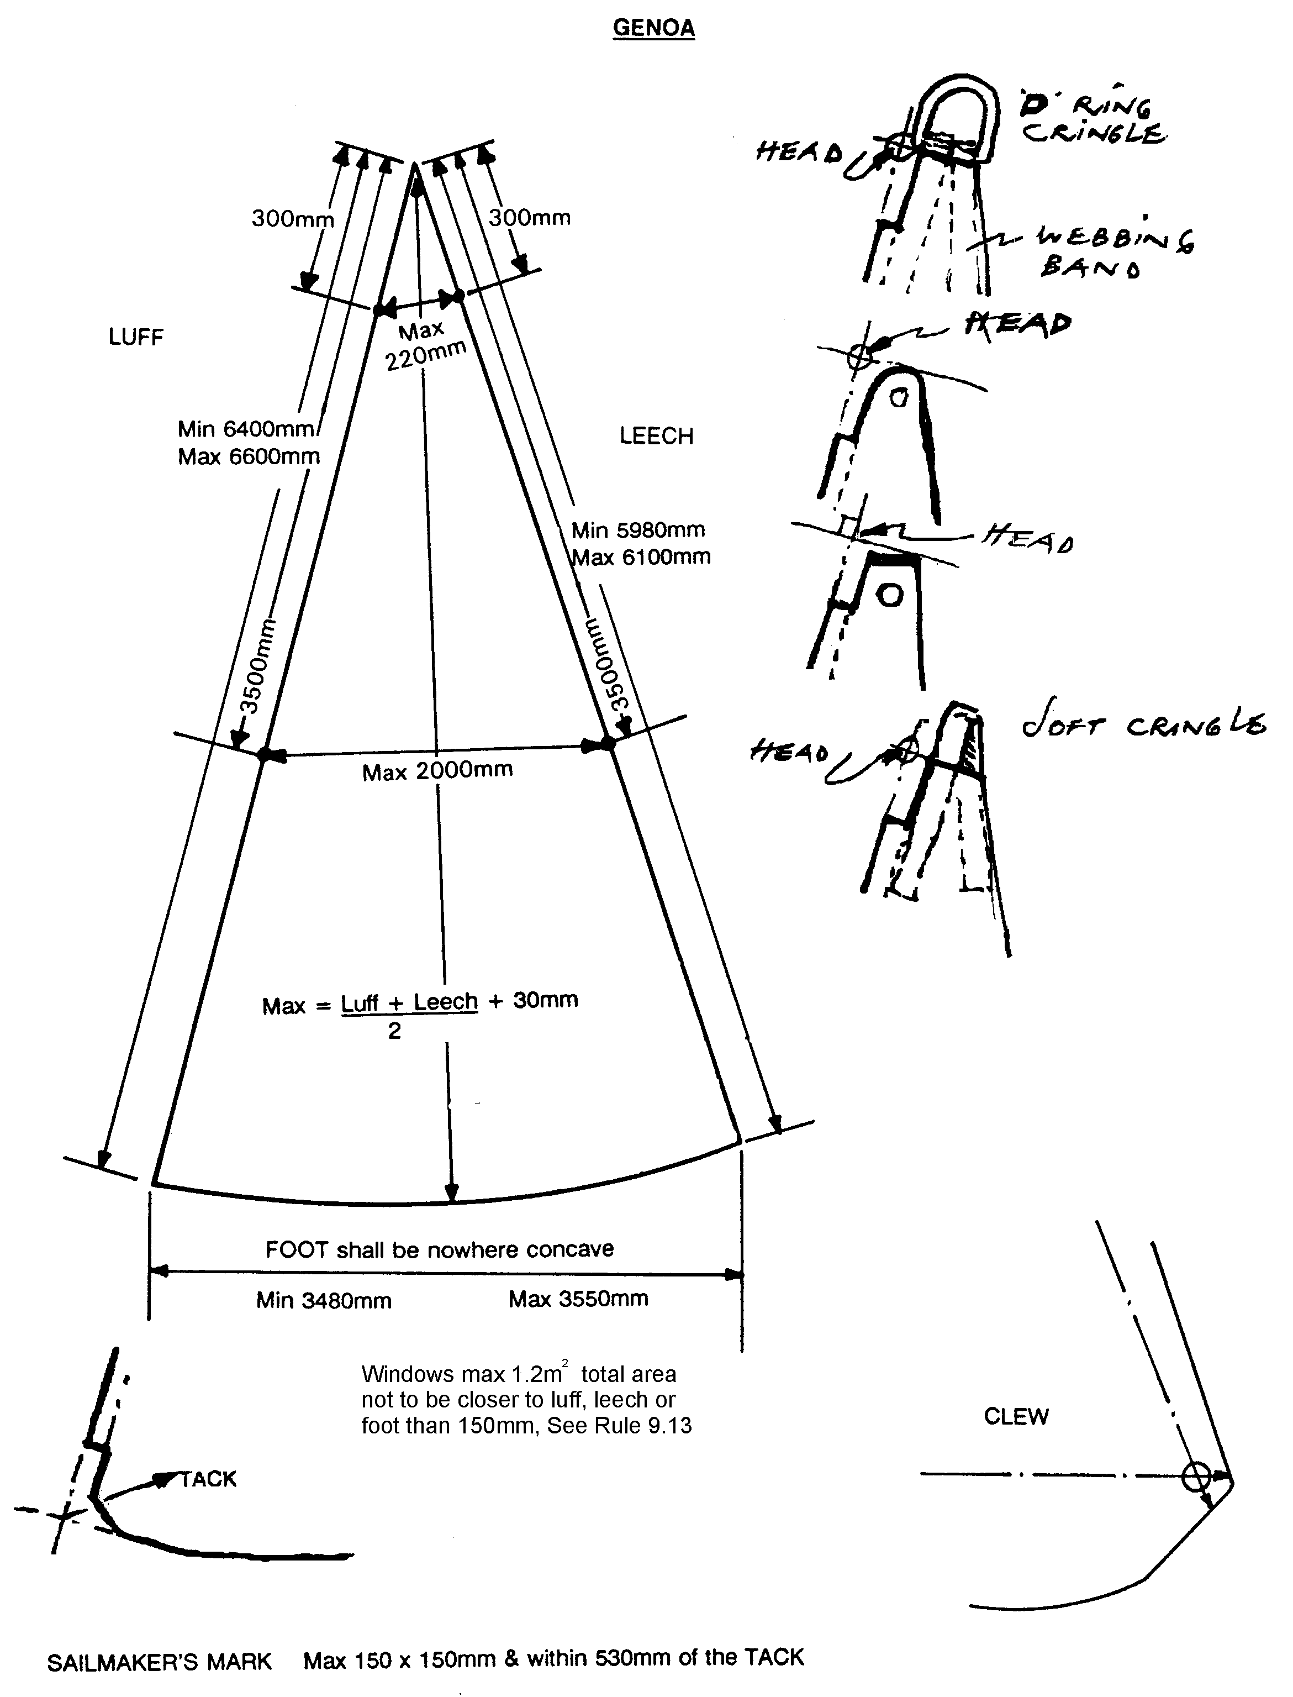
Rule 9.30
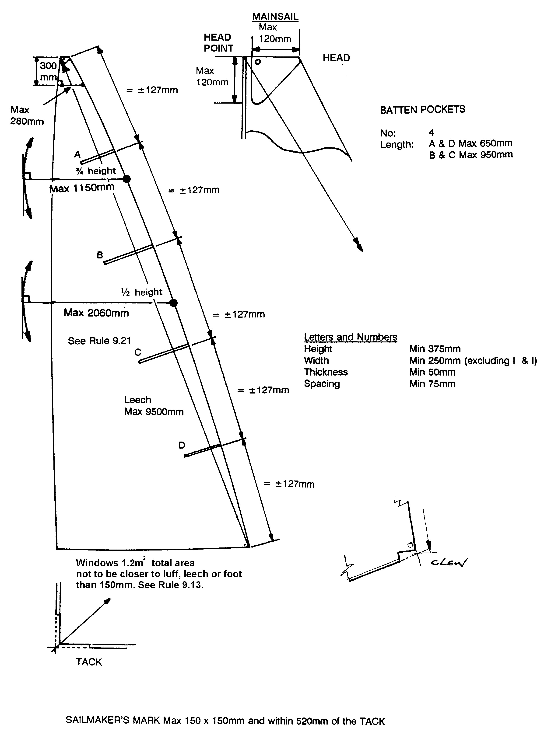
Rule 9.20
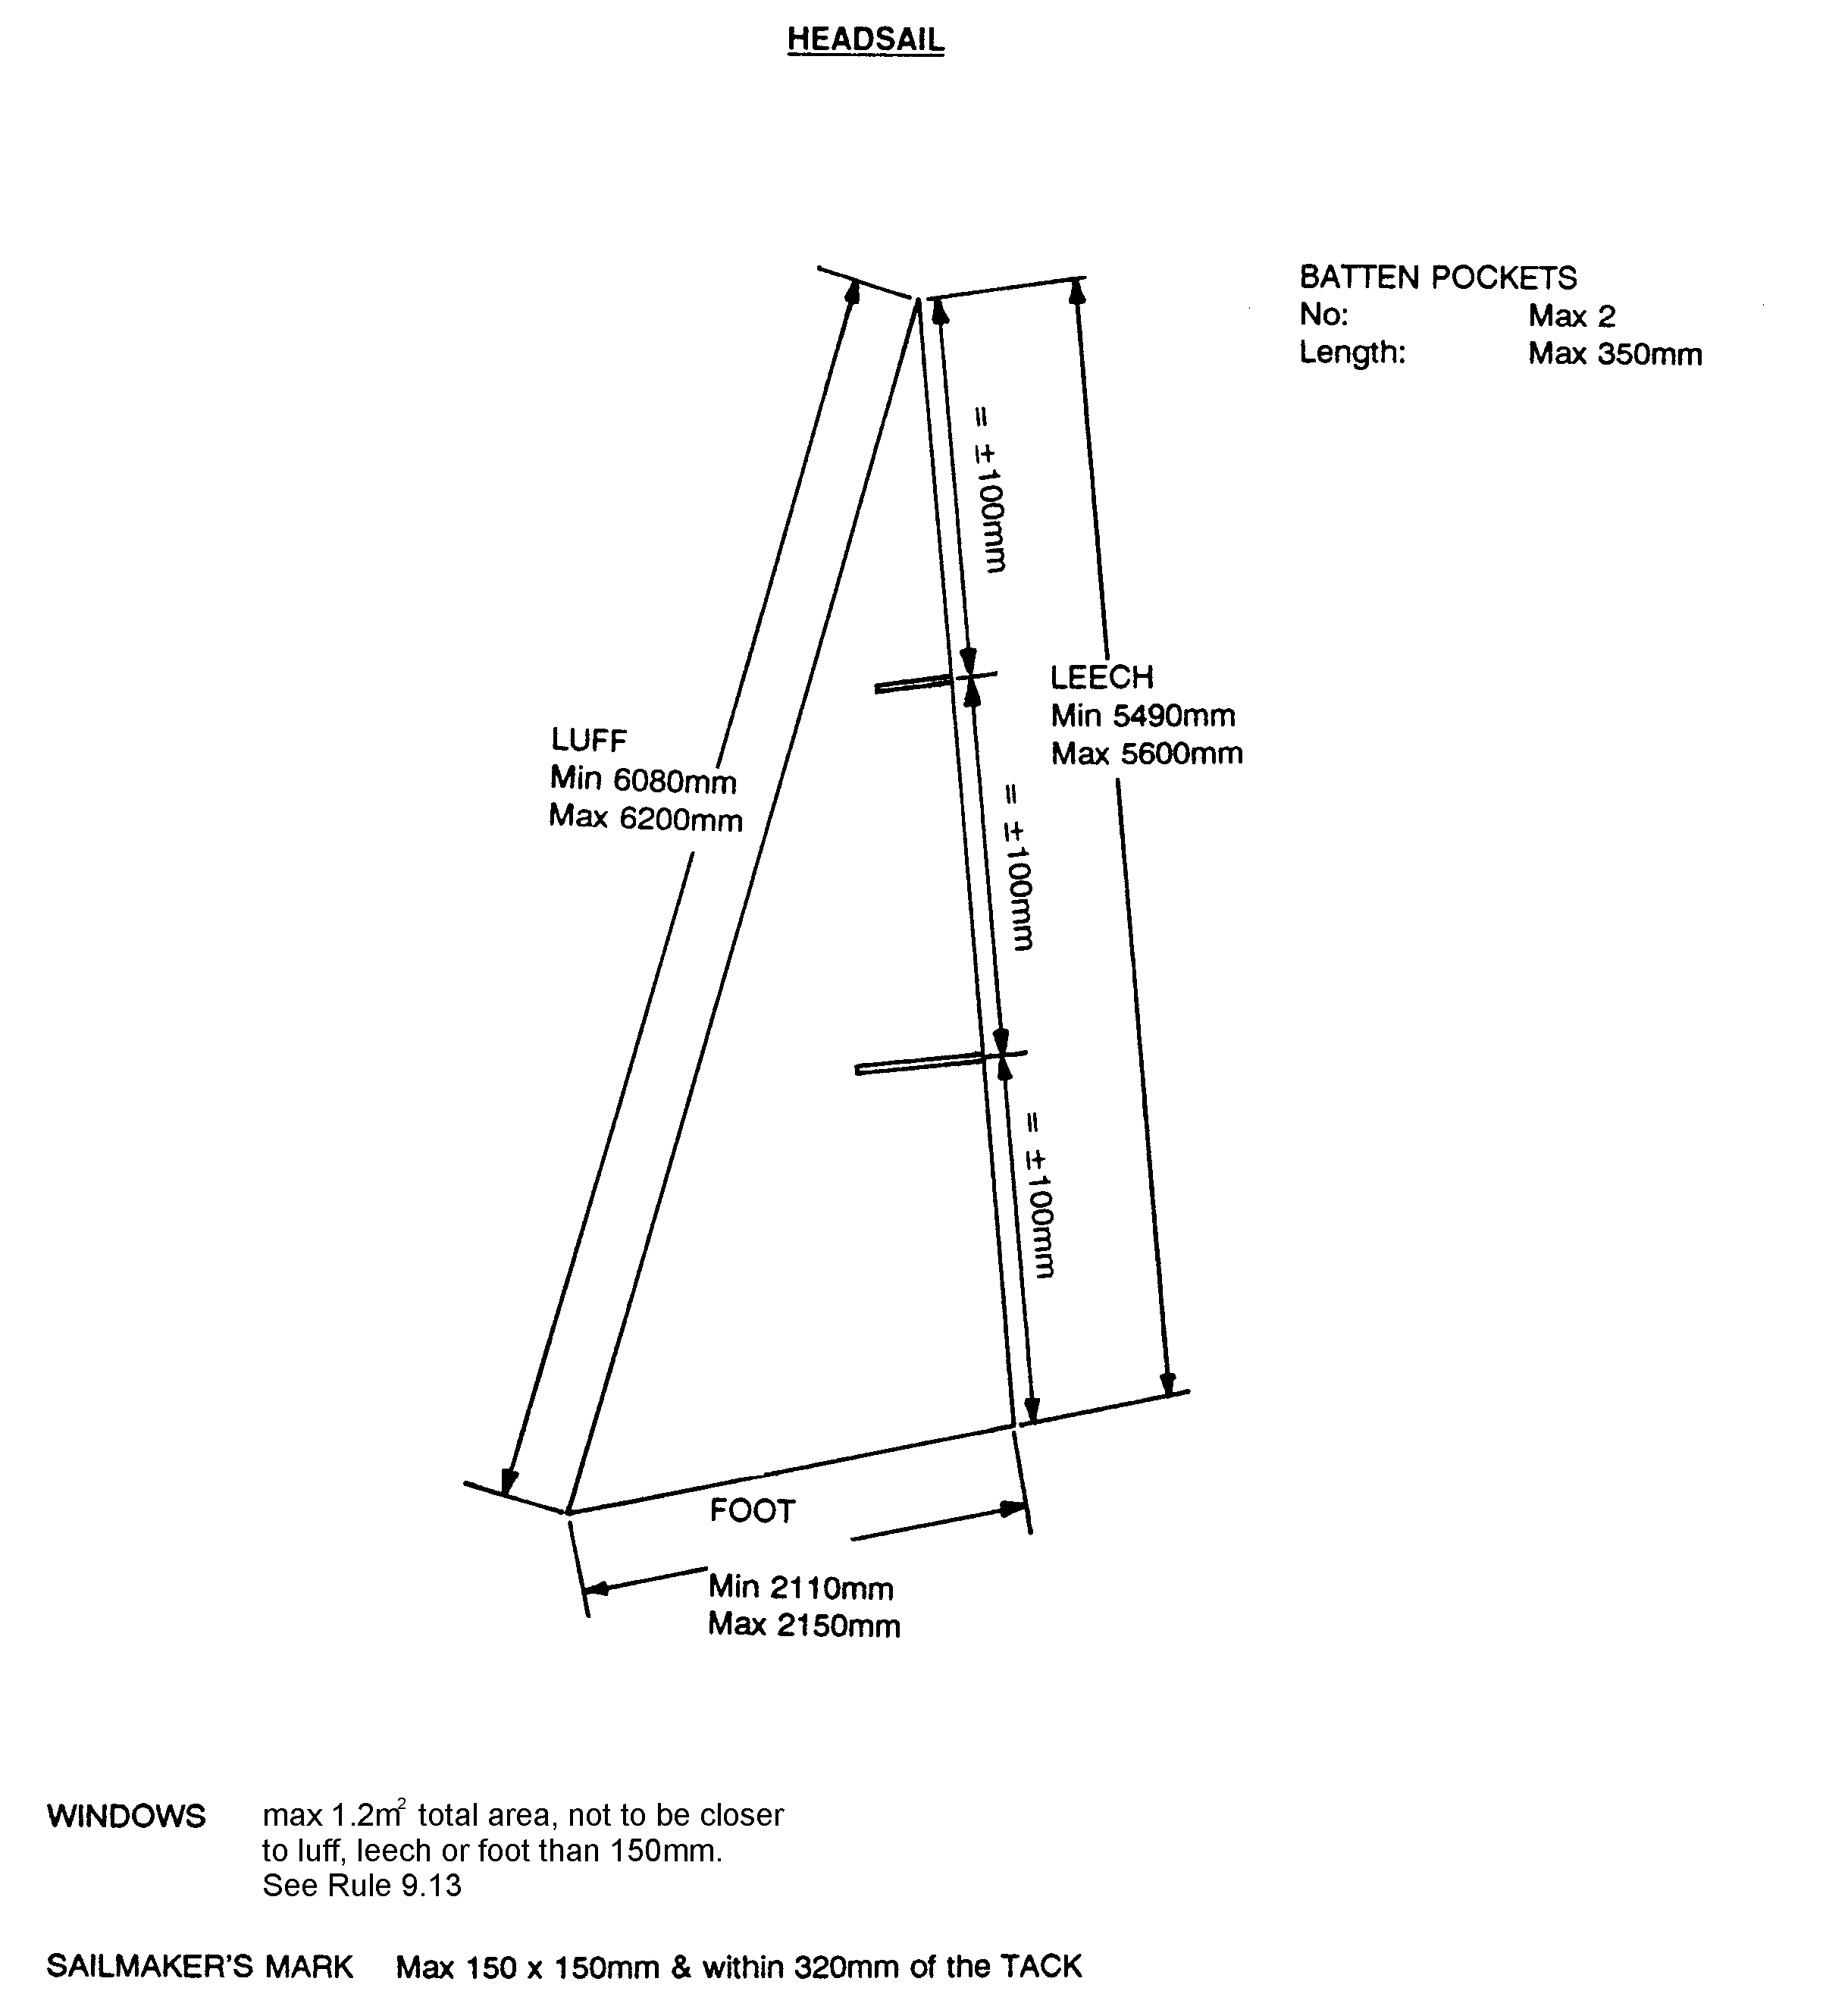
Rule 9.40
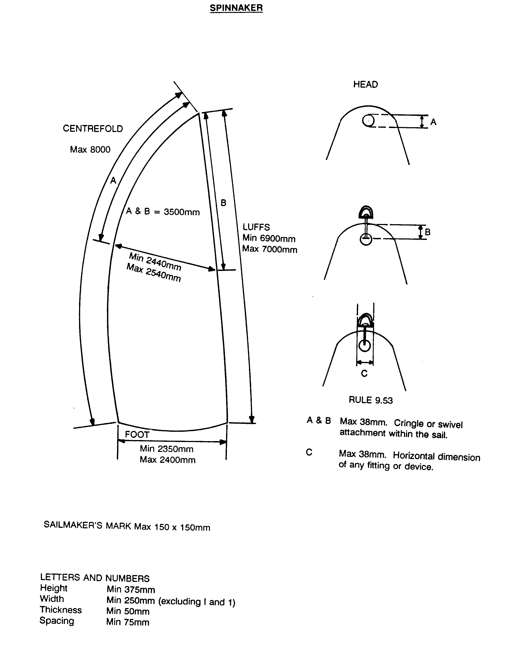
Rule 9.50
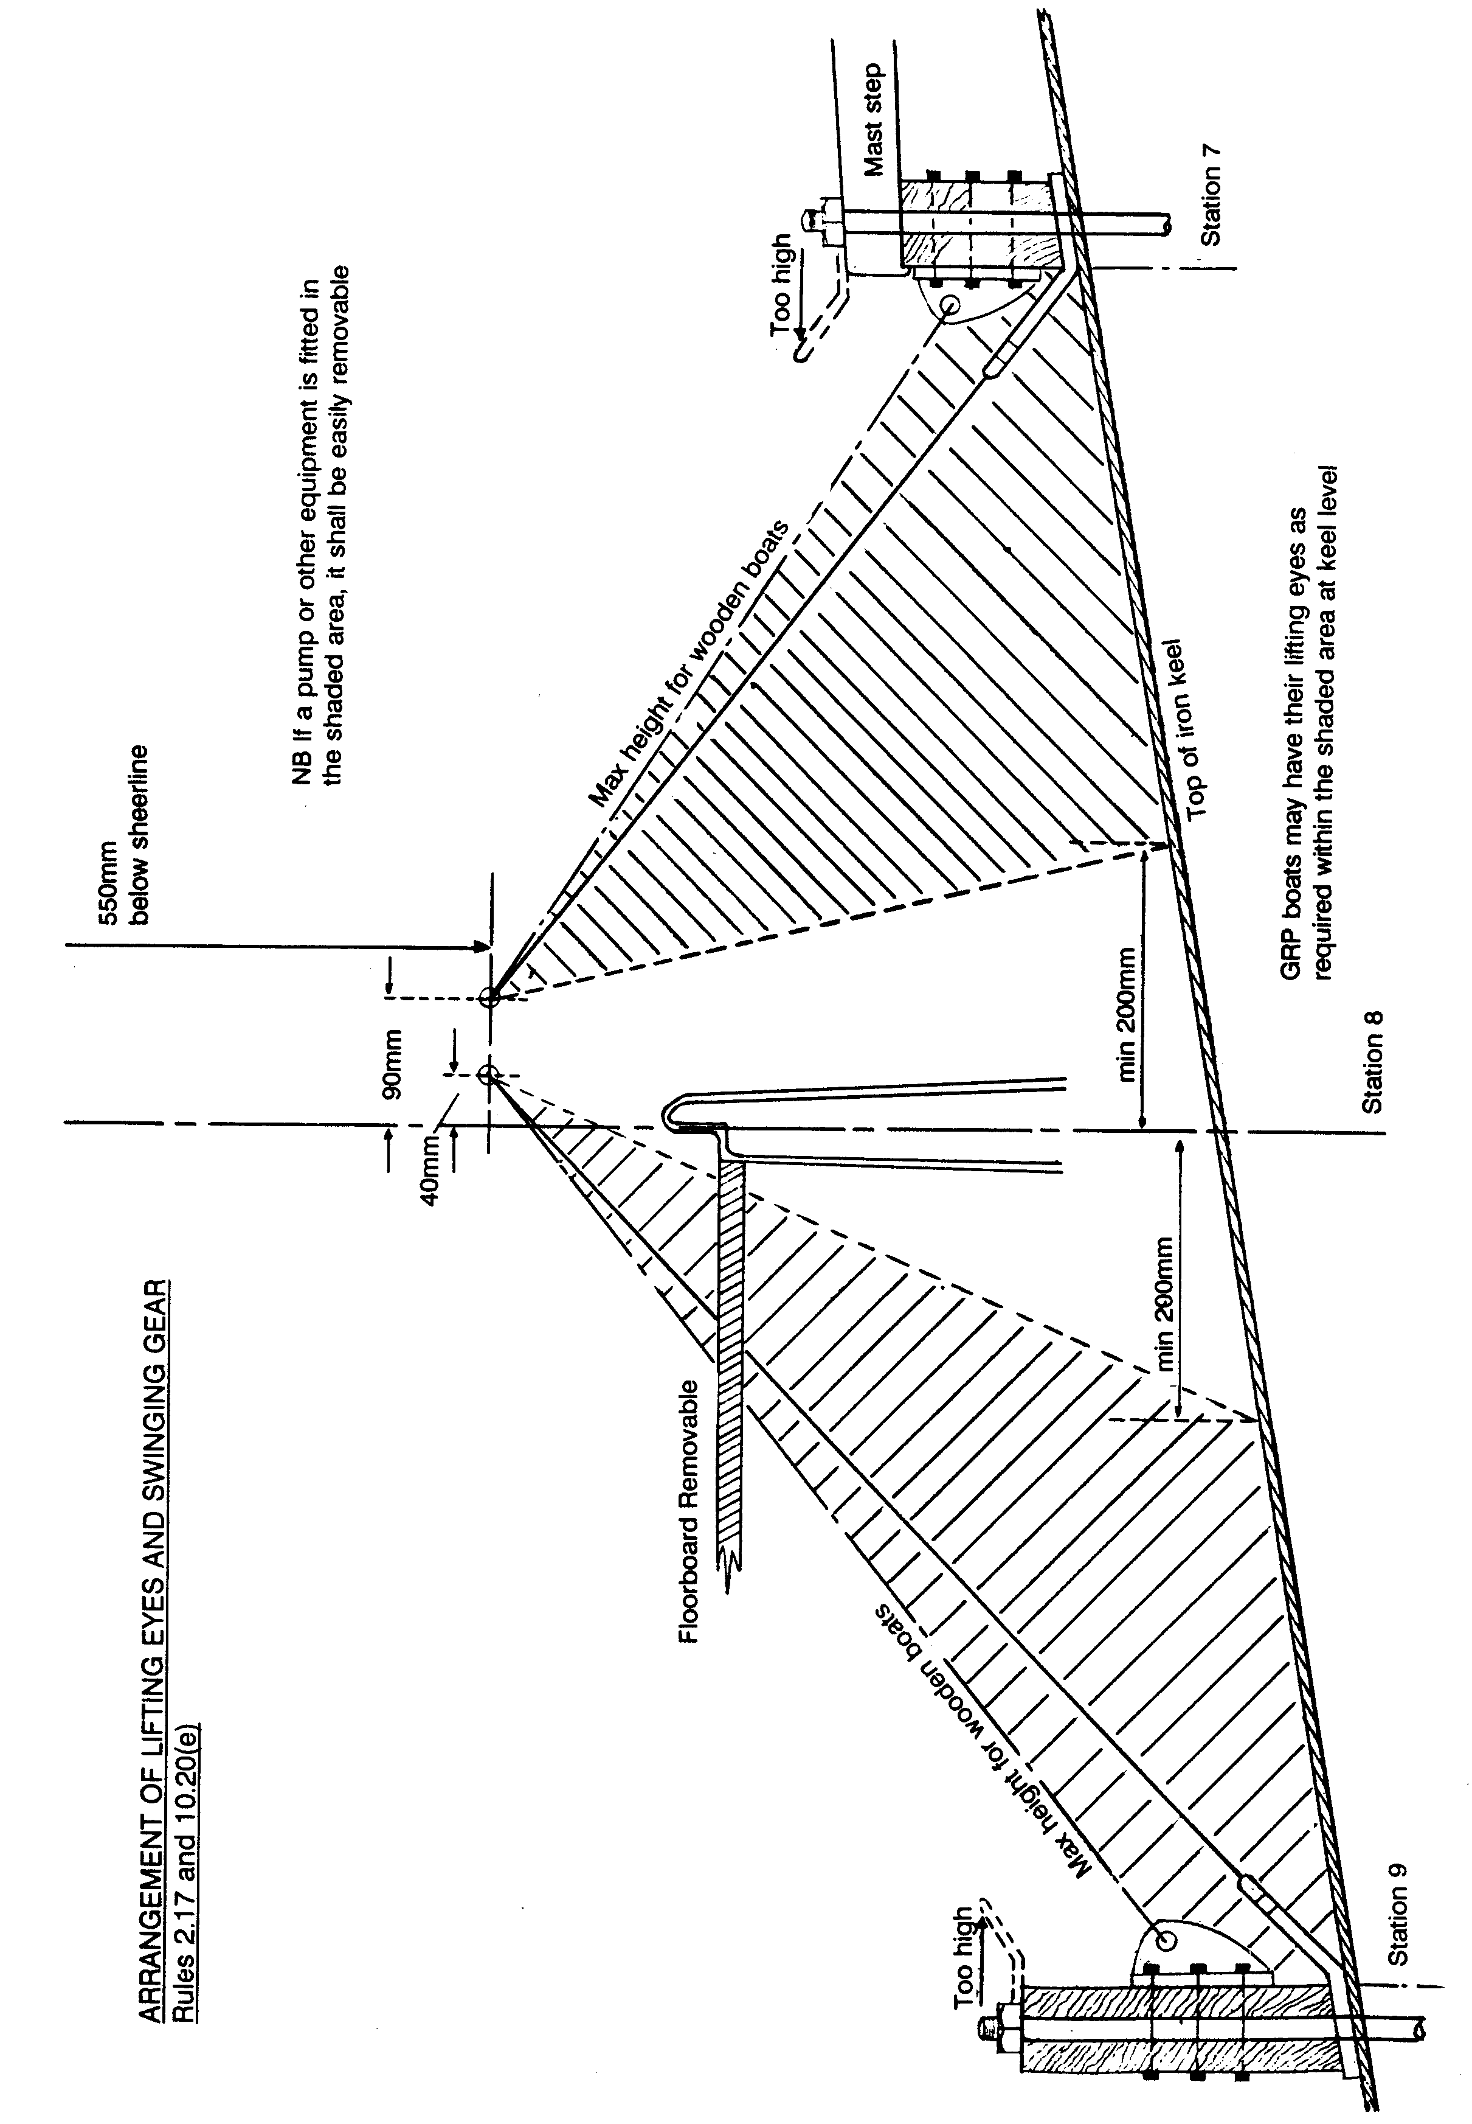
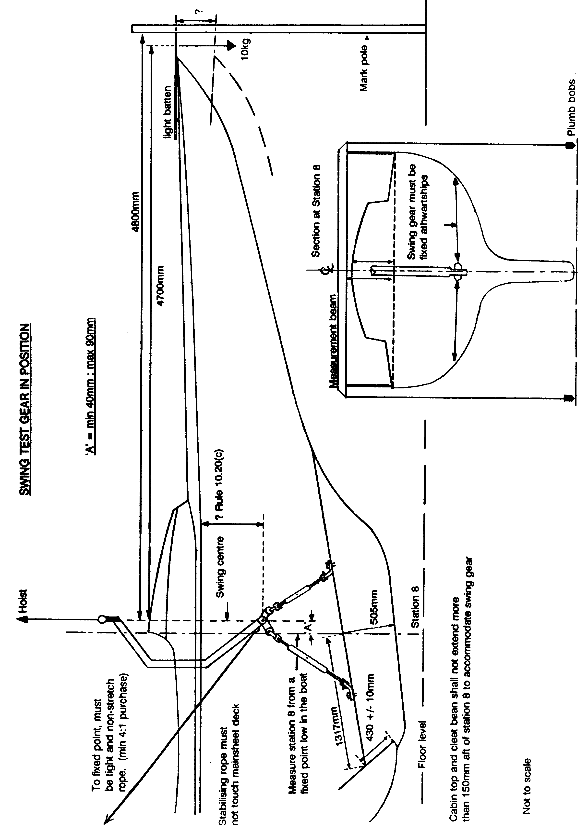
HULL TEMPLATE PROCEDURE

- Since I February 1952, the hull shape of all Dragons constructed has been checked by hull section templates. It was then decided that the shape of the hull stations may vary from the dimensions given on the table of offsets and the lines body plan by not more than ± 0.5%of the half station circumference at the following stations:
Station Tolerance Max Distance outside hull to template
2 ± 5mm 10mm
4 ± 5mm 10mm
6 ± 7mm 14mm
8 ± 8mm 16mm
10 ± 7mm 14mm
12 ± 5mm 10mm
14 ± 5mm 10mm

- The shape at Stations 2,4,6,8,10,12 and 14 shall be checked with ISAF registered and IDA approved templates.

- It is the responsibility of the License holder to mark the stations in accordance with Rule 2.15.

- The Measurer shall check the positions of these marks and the compliance of templates with plan 8 previous to applying the hull section templates. The measurer shall report any departure from plan 8 immediately to the IDA.

- When applying the hull section templates, they shall be set the correct width over the deck at the covering board plus the allowed deviation at each measurement station. At stations 6 and 8 the templates shall be attached to the support round the rudder as shown in Plan 3. When applying templates the levelling bars/holes shall be sighted in line (in transit).

- Position the template with its centre-line coincident with the centreline of the boat initially, and with one face of the template coincident with the station markers.

- Equalise the clearance between template and hull until the station to be measured fits comfortably within the permitted limits. When moving the template sideways, care has to be taken to keep the levelling bars aligned.

- Measure the clearances all around the template.

- Measure height of sheerline on each side.

- Record the greatest and smallest dimension measured in the measurement form.

STEM TEMPLATE PROCEDURE

Assembly

The angle bracket supplied with the template must be permanently fixed to the station 2 template ensuring that the stem template is on the centreline and that its base is at the correct height as shown in Plan 3.

Use

1. All templates must be correctly positioned and the stem template fixed to the angle bracket on station 2.

2. With the stem template in its forward most adjustment, move it aft until it touches the stem at least one point.

3. Check and adjust (moving template forward if necessary) height of the template sighting the level bar with those on the station's templates.

4. When the template is level with the station's templates and touching the stem at at least one point, check the clearance is within the 0-10mm tolerance permitted, check that sheerline height is within the marks and that the datum line is inside the allowed minimum 4680mm and maximum 4729mm distance forward of station 8.

- Lightly pencil the 100mm and 750mm scribe marks on the hull from the template. On removing the stem template check that the rounding of the stem does not exceed a diameter of 9mm between these points.

SWING TEST PROCEDURES

This test must be conducted indoors in a draught-free environment. An electric hoist will make the test easier.

Checking measurement marks at Station 8

1. Check or place the station 8 mark on the upper edge of the iron keel. This is at 1317mm from the aft end of the keel. There is no tolerance on this measurement.

The aft upper edge of the iron keel can be found at 430 ± 10mm by measuring along the aft face of the keel and at station 8 the upper edge can be found at approximately 505mm above the bottom edge. (The plans show this distance as 500mm). See diagrams on pages 29 and 30.

2. Check or mark stations 2 and 14 on the boat centreline. These are straight line measurements at 3672mm and 3695mm respectively, from station 8. Using stations 2 and 14 level the boat about her waterline with a water level or a surveyors level. REMEMBER STATION 14 IS 110MM HIGHER THAN STATION 2.

3. Checking that sheerline station 8 marks are square to the centreline (equidistant from the stem on both sides) place a straight measurement beam in position at this station.

4. Using plumb bobs from both ends of the measurement beam, adjust until the lines are on the sheerline marks. With a straight edge under the keel, sight the lines onto the hull and check that the station 8 marks on the keel are within the tolerances. Rule 4.60.

5. Measure and record the height of the coach roof or some other exact point above the sheerline. This will be used later to determine the height of the swing centre.

- Mark station 8 on the cabin top.

- With a plumb bob from the measurement beam or aft side of the cabin top record a measurement from some fixed point (close to station 8) within the boat, to station
- Remember to correct for the distance between plumb line and station 8 on the cabin top. This measurement will be used to determine the position of the swing centre fore and aft.

- Tape a level to the deck, adjusting so that it is horizontal and parallel to the centreline. This will provide a constant reference that the boat is hanging horizontal.

The Swing Test

1. Weigh the boat with the mandatory gear on board. Place eventual corrector weights temporarily on each side approximately 70mm forward of station 8 and at approximately 570mm below the sheerline.

2. Install the swing test gear. The swing centre should be approximately 70mm forward of station 8 and approximately 570mm below the sheerline, or as low as possible. Remember to tie the boat athwartships from the swing centre.

3. Lift the boat and using the previously attached level make sure the boat is hanging horizontal from the swing gear. Adjust as necessary, but ensure the swing centre is kept as low as possible.

4. Lower the boat until it just touches the ground and support it sideways. Using the fixed points taken in previous steps 5,6 and 7, measure and record the distance the swing centre is below the sheerline and the distance the swing centre is forward of station 8. Mark the position of the swing centre on the cabin top.

5. Check and tighten all the fastenings on the swing gear to ensure no possible movement.

6. Place a light batten on the foredeck with its forward end exactly 4800mm forward of the swing centre mark on the cabin top.

7. Lift the boat again and check that it is still level. With a vertical stick mark the position of the foredeck batten with the boat at rest.

8. Hang 10kg 100mm back along the foredeck batten to be exactly 4700mm forward of the swing centre. Measure and record how much the stem is depressed at the end of the foredeck batten. Remove the 10kgs.

BEFORE STARTING THE SWING TEST, THE SWING GEAR MUST BE
STABILISED.

A purchase system (of at least 4:1) of non-stretch (spectra or kevlar) must be attached to the eye on the swing gear and a suitable point on the building at an angle of not more than 45 degrees to the horizontal. THIS LINE MUST BE TIGHT AND THE SWING GEAR SOLID AND WITHOUT MOVEMENT. THIS IS VERY IMPORTANT.

9. Depress the stem by about 350mm and release. After the stem has gyrated through 1½ complete cycles, take the time for 10 complete cycles, starting and stopping as the stem descends past horizontal. Take the times independently with 2 digital timers using hundredths of a second. Complete the swing procedure twice and average the results. Work these results through the requirements of rule 10.20.

10. If the measurement and times taken do not correspond to the rules, corrector weights must be moved or added so that the height and fore and aft position of the swing centre, as well as the period of gyration fall within the tolerances specified in the rules.

© International Sailing Federation Effective: 1 March 2001

